Badger Farm Community Centre Spring Quiz for Kids

-Big and Small!

Join in our Spring Quiz for Kids and help us all find out more about the wildlife that lives around us.

Have a look round your garden, street, park and anywhere else you go to see what you can find. Investigate and tell us about some of the things you see. We’d love you to send in some pictures or photos of what you find. If you can, tell us where you found these things.

You can do this on your own or with a grown up.

Return your entries to us at Badger Farm Community Centre or email them to bfobrca.enquiries@gmail.com clearly marked “Spring Quiz for Kids”. The first 30 children in KS1 or KS2 who send back their entries will get a special little pack to help get their spring started. Make sure you ask the grown up who looks after you to complete the details when you return your completed quiz so we can contact* you if you are one of our lucky 30. (Arrangement for collection of any prizes will be made after the prizes are allotted).

*Names and other personal details shall be used solely for the purpose of the quiz and distribution of prizes and not otherwise retained – see our privacy policy for further details (available on request) and will not be shared with any other organisation.

Your Name…………………………………………………………………………………

Age/year group…………………………………………………………………………….

Address…………………………………………………………………………………….

Parental Contact email……………………………………………………………………

Parental/Carer’s Consent:
Parent’s/Carer’s Signature………………………………………………………

Parent’s/Carer’s Name (please print)…………………………………………..

Quiz Questions
- There are lots of spring flowers coming up. Which ones have you found?
Daffodil | 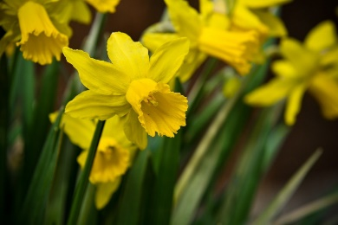 | Lesser Celandine | 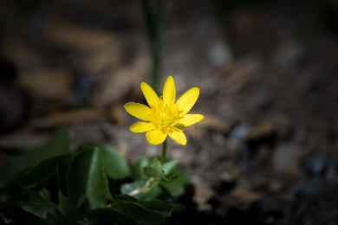
Crocus | 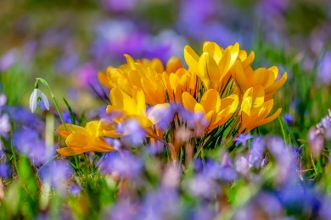 | Wild Anemone | 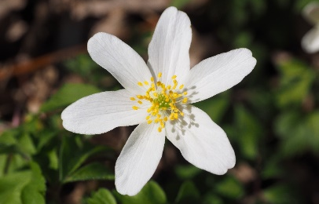
Snowdrop | 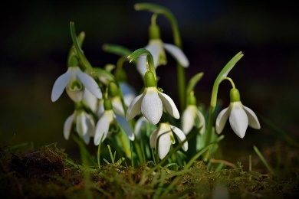 | Daisy | 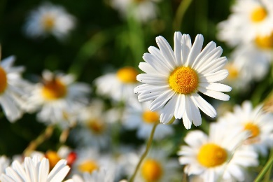
Primulas/  Cowslips | 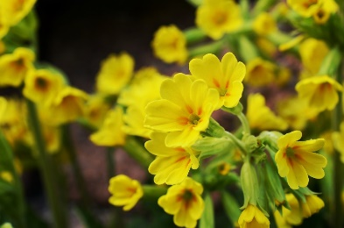

Tell us about any other flowers you have seen.

Bluebells aren’t out until April but do let us know if you see any.

- There are some bushes which are coming out with bright yellow flowers just now.
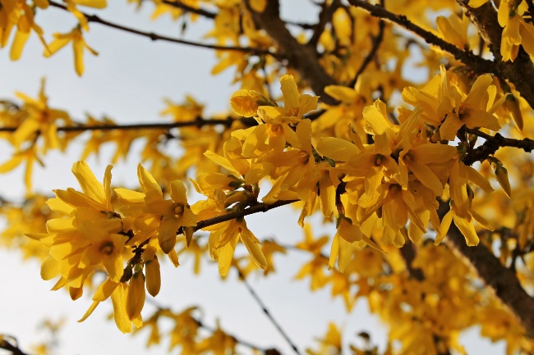
- What is this plant called?
- Bees don’t like it much, but it provides cover for lots of small animals and birds. Some birds enjoy its flower buds, too. Can you think of any animals it might shelter?
- Can you find and list any other plants that also provide cover for mice and hedgehogs?

- Can you think of any other plants, bushes or trees that provide birds with food during the winter and early spring (either nutritious buds or berries)?
- Lots of our wildlife hides away during the day, but you can see signs of them.
Have you found any molehills or hedgehog droppings? Tell us about what you’ve found and where you found it. You can take a picture and send it to us.

- See if you can find these trees. Tick the boxes for the ones you’ve seen
Crab Apple | 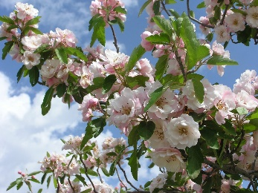 | Sycamore | 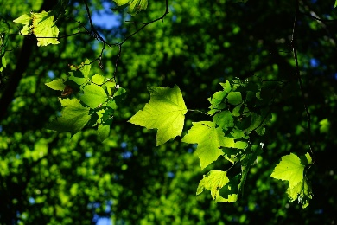
Beech | 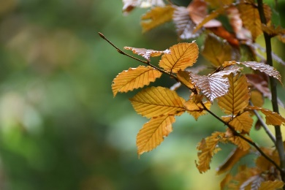 | Rowan | 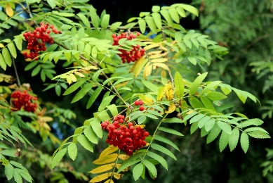
Birch | 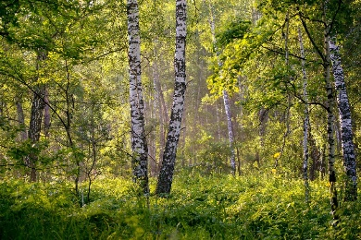 | Hawthorn | 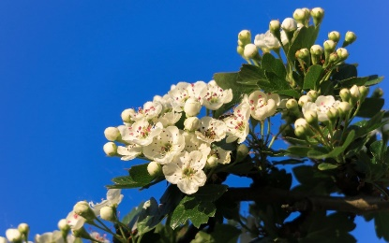
Hazel | 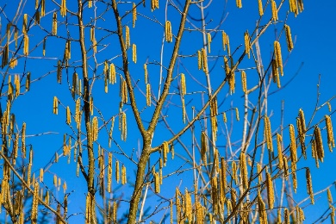
Have you seen any other trees? Write a list here:

- Winchester City Council and the Parish Council are trying to grow more wildflowers, trees and bushes around us? Can you find where? Tell us where you found them. You can take a photo or draw a map or a picture.

Draw your picture here:

- We love hedgehogs. Are there hedgehogs in your area? Tell us about them.
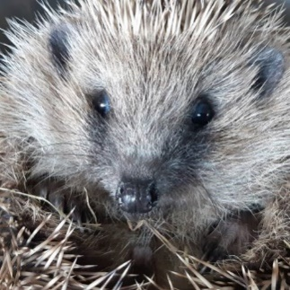
- How do you know they are there?
- Do you look after them or help them? Tell us how.

- Is there is a hedgehog path/highway near you (hopefully not across a road)? Tell us about it or draw a picture or send us photos and there may be a special prize for you.

- Have you seen any of these birds? Tick the boxes for the ones you’ve seen.
Sparrow | 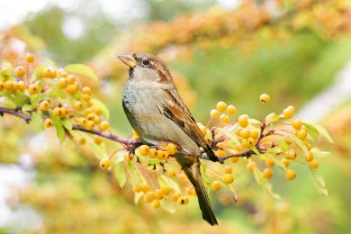 | Wagtail | 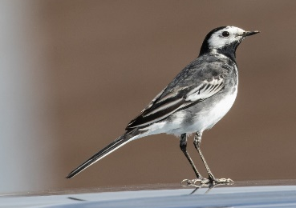
Wood pigeon | 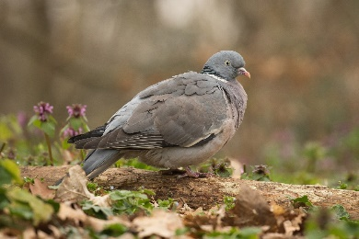 | Bluetit | 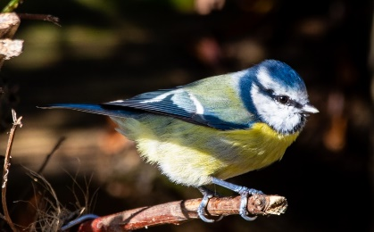
Collared Dove | 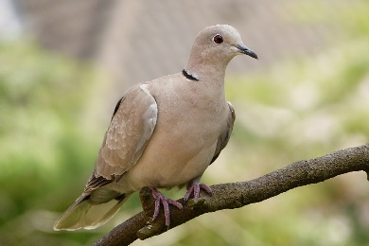 | Wren | 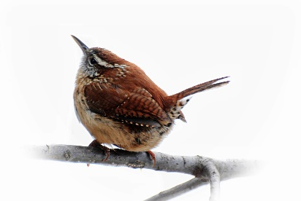
Blackbird | 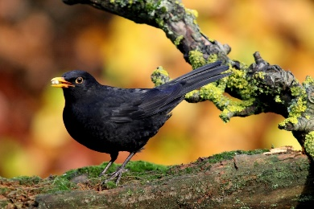 | Longtail tit | 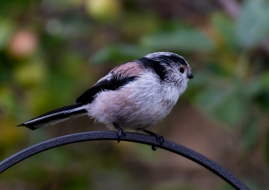
Robin | 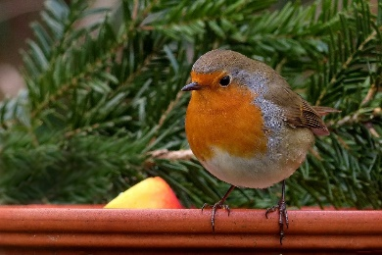 | Coal tit | 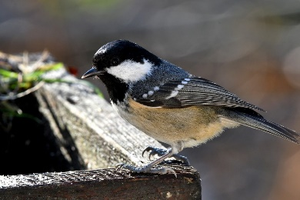

Have you seen any other birds? Write a list here:
- At the start of spring, insects become active. Which insects have you seen?
  - Honeybees or solitary bees
  - Bumble bees
  - Butterflies
  - Moths (not all of them just come out in the night)
  - Woodlice
  - Ladybirds
  - Wasps
  - Boxelder Bugs
  - Flies
  - Beetles
  - Other insects. List them here:

Remember not to clear up the piles of leaves left over from the autumn just yet as the bugs are snug in them.

- In England there are not many animals that hibernate. Can you name any?

Keep an eye out them because they will be waking up soon. (Avoid trimming the hedges and check before doing any work.)

- Pampas grass attracts different wildlife, especially in the spring
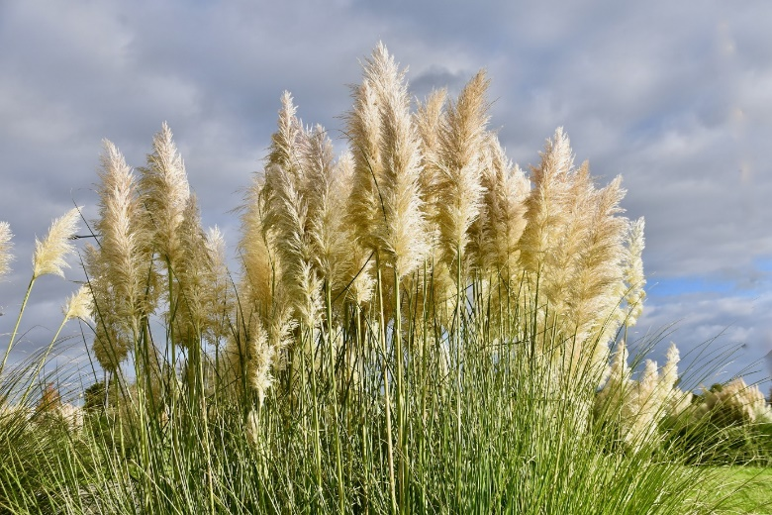
- Have you seen any pampas grass growing around Badger Farm or Oliver’s Battery? Tell us where.
- Which animals are making use of the fluffy heads now and why?
- Who could be nesting or sleeping in last year’s brown pampas grass leaves?
Remember not to burn, cut down or trim the dry leaves or cut down grass stalks, even if they look messy at the moment. Wait until later in April, and check for any nesting animals before doing any work.

- Some birds like to feed above the ground, in the shrubs or trees. Other birds like to feed on the ground (they are called ground feeders). We like to put out food for the birds. Here is an example of our bird table diner.
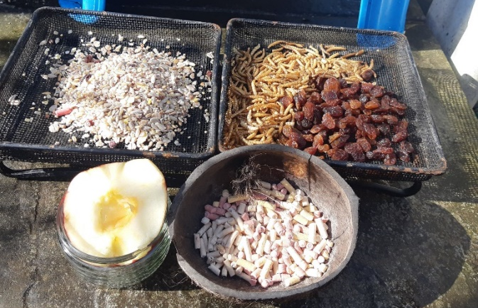

Can you list three (or more if you can) types of birds that would enjoy it?

Tips for Bird Feeders

Remember:
- Disinfect your bird feeders regularly (food gets mouldy and dirty feeders can harbour harmful bacteria).
- Put out clean water in shallow dishes – birds and hedgehogs will thank you for that! (A ping-pong ball in the dish should prevent the water from freezing in frosty weather.)
- Make sure to remove mealworms, sunflower hearts and raisins from the ground feeders for the night as these foods are harmful to hedgehogs. Apples can be enjoyed by both. (Alternatively, put the feeders on a step, out of hedgehogs’ way.)
- You can use a stool to shelter the food from the rain, if you have one.

